|  |  |  |  |  |  |
| --- | --- | --- | --- | --- | --- |
| Date | 12-Dec-22 | | | Tester Name | Mayuri Patel |
| Environment | Penfax - Test | | | Login used |  |
| Operating System | Select OS | Version: | Update: | | |
| Software Used | Select Software | Version: | Update: | | |
| Select Software | Version: | Update: | | |
| Release version | 22.4.1 | | | | |
| Title |  | | | | |
| Test Type | Regression | | | | |
| Test Scenario | Process PEPP New Pending Report | | | | |
|  |  | | | | |
| Expected Results |  | | | | |
| Pass/Fail | Pass | | | JIRA# | N/A |

Describe your steps with screenshots:

Search Batch processes for PEPP New pending Report

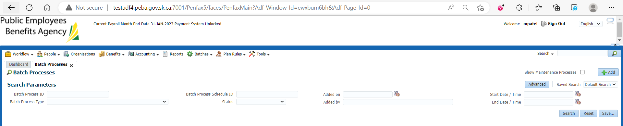

Lists all batches of that kind

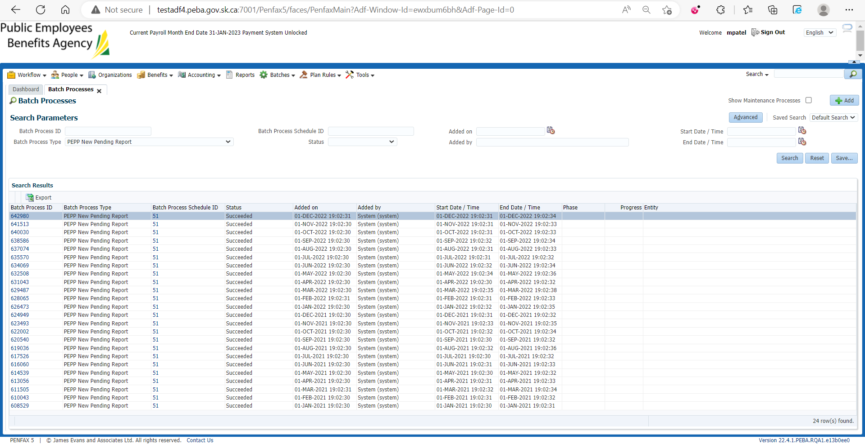

Select any Batch Process ID

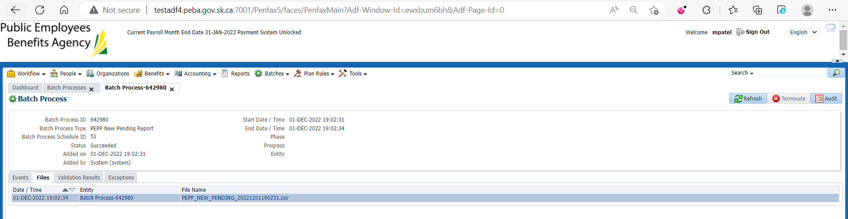

In the selected batch process ID under files tab new pending report is found

Download that report and from that report choose any member and search for member in member search in Pen fax

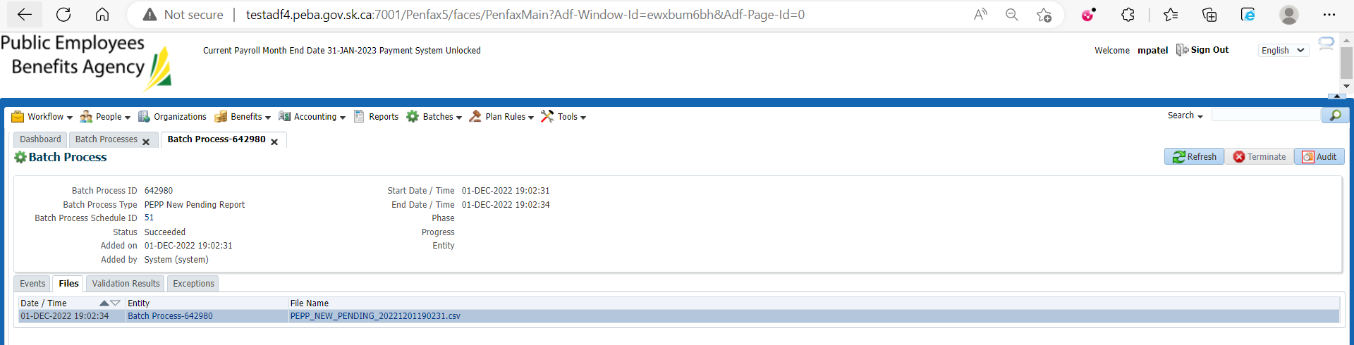

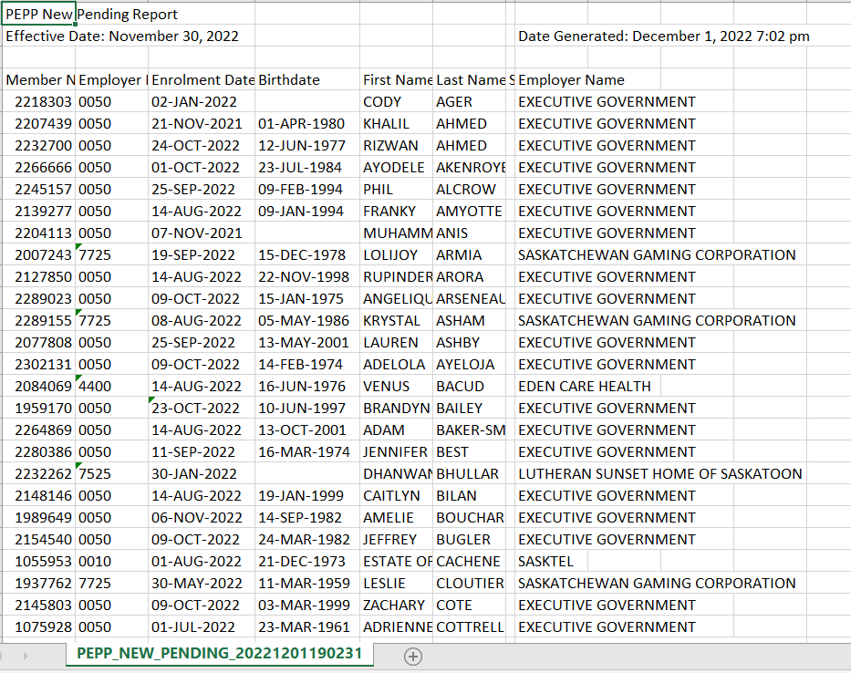

Member status is Pending for that member

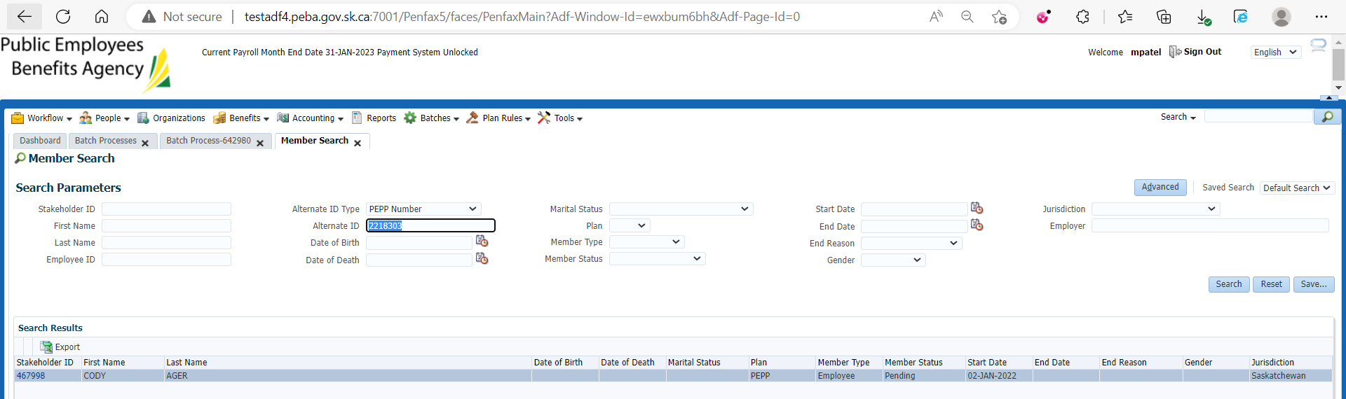

Likewise choose another member from CSV file and search for that member in Pen fax to make sure the member status shows pending

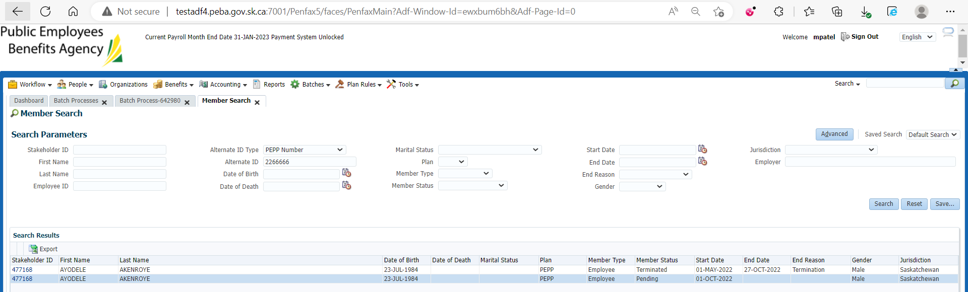

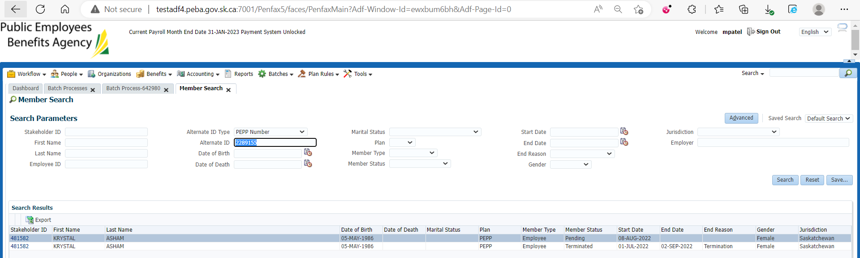

PEPP_NEW_PENDING_20220601190231.csv is saved at: H:\Quality Assurance\Prod Apps\Testing Management\Regression Testing\Nov 2022 - PENFAX 22.4.1 Release\PEPP\Test Results\E15 Reports